What is the Burnbanks project about?

- A model village was built at Burnbanks in the 1920s to house Manchester Corporation workers constructing the Haweswater Reservoir and Dam. In the 1930s, 315 adults and their families lived there. After the Second World War, some houses were taken down and numbers dwindled. Today, Burnbanks has few occupants and there are plans to demolish and rebuild the surviving bungalows. The Bampton Local History Society has been awarded a Local Heritage Initiative Grant by the Countryside Agency to study the history of Burnbanks from 1920 to the present day. Completion date for the project is December 2005.

What are we doing?

The aim of the project is to collect information about life at Burnbanks and to interview people who lived, worked or visited the village. We intend to do this in various ways –
- researching in archives
- studying local newspapers
- collecting and conserving existing photos and records
- photographing and measuring the existing site
- recording people’s memories

We would like to hear from you!

Please contact us:
- for more information
- if you have items (photos, letters, press cuttings) that could be useful
- if you have memories of Burnbanks old or new to share
- if you can help – researching, interviewing, transcribing or summarising recordings, photographing, and much more!

Talking of Burnbanks

Programme:

11.00 am Exhibition opens
12.00 noon Recording Memories of Burnbanks
- who we would like to interview
- how we plan to do it
- what will happen to the recordings
1.00 pm Lunch Refreshments
2.00 pm Talking Burnbanks
Your chance to -
- Tell us what you know
- Show us any memorabilia you have
- Talk about how you can get involved
3.00 pm Open Day closes

Contacts:
Bampton Local History Society
Bryham House
Low Knipe
Bampton
Cumbria CA10 2PU
Tel: 01931 713 294

Website: www.bampton-history.org.uk

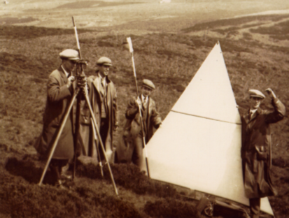

Talking of Burnbanks

Open Day

Saturday 24 January 2004
Memorial Hall, Bampton
11.00am – 3.30pm

